December 4th, 2011
Hi
Since the recent district council elections in HK, there have been many revelations of vote rigging. It turns out that many people have been registering with the same home address in various constituencies. In some cases this is serious as the winners in some constituencies won by just a few votes. An investigation is under way. Similar problems occurred in the previous elections a few years ago. Again, an investigation was carried out, but the government said it did not have the (financial) resources to pursue it further (translation: they did not want to do anything!).
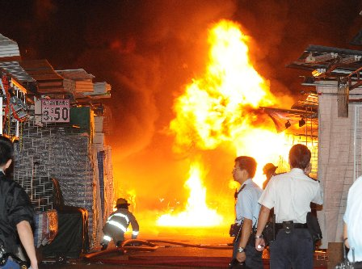
On Tuesday, there was an early morning fire, suspected to be arson, in the Fa Yuen Street hawker stalls in Mongkok. The fire spread to adjacent buildings and in one killed 9 and injured more than 30. All the people killed were found on one of the staircases in the building. This building is one in which flats have been sub-divided into very small units. Because of this, one of the emergency exits was unavailable for most of the tenants as it was available to just one of the sub-divided units. Unfortunately, the only escape available for most residents turned out to be a death trap. Here are two videos of the fire:
http://edition.cnn.com/2011/11/29/world/asia/hong-kong-fire/?hpt=hp_t3
http://www.bbc.co.uk/news/world-asia-china-15965477
A similar fire occurred in the same street stalls about a year ago, though that one did not spread to adjacent buildings.
There has been a lot in the news on the visit to Burma by Hillary Clinton, the first visit by a US official since 1995. It will be interesting to see if the small changes that appear to be taking place are for real or not. Recently, elections were held in which a civilian government took over from the military though it is still dominated by military as many seats were reserved for them. China is not too happy about the changes that have occurred and what may still occur. The new Burmese government recently blocked construction on a huge hydroelectric project being built by China, who would get to use all the electricity produced. In the latest Time magazine, there is a comment that the military senior brass in Burma is wary of China as they have spent most of their lives fighting insurgents supplied by China.
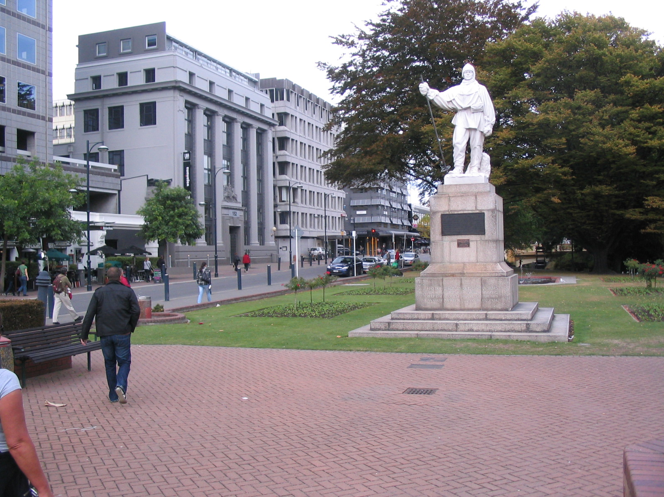
100 years ago on Friday, the first Australian Antarctic expedition set off from Hobart. There were celebrations there to remember it, some of which were shown n Aus TV. They set off just a few weeks before the team led by the Norwegian explorer Roald Amundsen reached the South pole (on December 14, 1911). This was about one month before the ill-fated expedition of British explorer Robert Falcon Scott reached the pole only to find that they had been beaten, and all of whom perished on the return journey, with the last three being just 10 miles from their food and fuel depot. Christchurch played a part in Scott's expedition (and his earlier one about 10 years before) as it was from the port of Lyttleton that they set off for the Antarctic (Amundsen used Australia). On the banks of the river Avon in the centre of Christchurch, there is a statue of Scott (shown here, which is a picture I took last year when in Christchurch).
The run yesterday was a bit tough, but at 2 h 13 min, was exactly the same time as last year. Although I did not know it at the time, the air temperature was only about 14⁰C. It didn't feel this cool and it was sunny with no wind (and probably as all the surroundings still had not lost a lot of the heat absorbed from the summer), but may explain why my leg muscles seemed to take so long to warm up.
And now for the terrible news. My rent here is set to double!!! This came into effect starting this month but for me it will be when the current lease expires at the end of May. I have to decide whether to stay here or find a flat somewhere. I really still need to be in HK for a while because of all the writing I am still involved with for the Singapore publisher. I suppose I could move to Singapore but then I would have to pay full resident tax on my income which, when added to the rent for a flat, would probably make it just as expensive as living here in HK.
That’s about all for this letter.
Cheers

